
Office of the Mayor
David J. Cieslewicz Room 403
210 Martin Luther King, Jr. Boulevard
Madison, Wisconsin 53703-3345
PH 608 266 4611
FAX 608 267 8671
TTY/Textnet 866 704 2340
mayor@cityofmadison.com

March 24, 2011

Dear Neighborhood Residents and Community Groups:

I am pleased to announce that the City of Madison is now taking applications for the 2011 allocation of Emerging Neighborhoods grant funds. The purpose of this City program is to enhance the quality of life in our challenged neighborhoods where lower income people live, particularly through innovative and grassroots approaches to neighborhood-based community building. This program provides a unique opportunity for neighborhood groups and organizations to develop and propose a broad array of neighborhood-initiated improvements and organizing projects. A neighborhood group may be established just to undertake a project – the group does not need to be “incorporated.”

Please review the attached Proposal Guidelines and Application Form to decide whether your group would be interested in developing a grant proposal. A total of $50,000 is available for distribution in 2011. This is expected to be the only application opportunity for the year. Applications must be received in the Mayor’s Office 4:30 p.m. on Friday, April 22, 2011 in order to be considered for funding. If you have questions or need further information, please contact the City staff listed in the Proposal Guidelines and Application form.

I look forward to receiving your ideas and proposals that will continue to improve the quality of life throughout our neighborhoods in the City of Madison.

Sincerely,

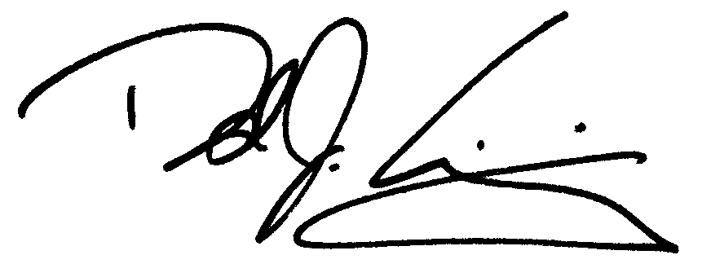

David J. Cieslewicz
Mayor

Enclosures

